**Introduction**

Most cities run on a solid foundation of tourism and having the local population explore their cities. Since both Toronto and New York are financial centers we can expect tourism being a big part of bringing new business into a city. Each city will have a different appeal of what attracts people to a given location versus another.

**Problem**

For tourism and thus local business to be successful then there must be ample appeal to an area. Since human beings are natural social creatures who seek out interaction with one another then we should see a high number of meeting areas to be present. I would expect cities to have a fair amount of recreation areas in nature for people to explore. For a city to sustain their population there must be adequate natural resources locally or they must be brought in. As you can see there are several dependencies for a city to be successful.

**Data**

Toronto has a smaller population at 2.9 million people with 630.20 km2 of city area. New York has closer to 9 million people with 1,212.60 km2 of city area. Tourism is popular for both cities because they offer museums, shopping areas, plazas, eating places and parks. I’ve used the data from the previous weeks work with k-means based on pulling information from foursquare.

Paragraph or two on the data.

Data where you describe the data that will be used to solve the problem and the source of the data.

Methodology section which represents the main component of the report where you discuss and describe any exploratory data analysis that you did, any inferential statistical testing that you performed, if any, and what machine learnings were used and why.

**Results**

The capstone objectives from prior week’s show us that a meeting places of coffee and café shops are important to both cities. Restaurants are equally important places based on what has been completed. One important difference between New York and Toronto is gyms/fitness centers which are popular in New York, but not important to Toronto.

New York

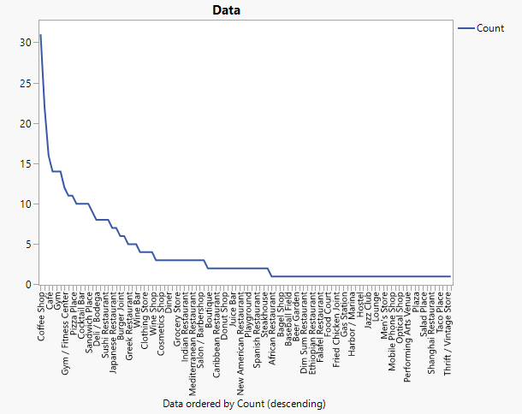

Toronto

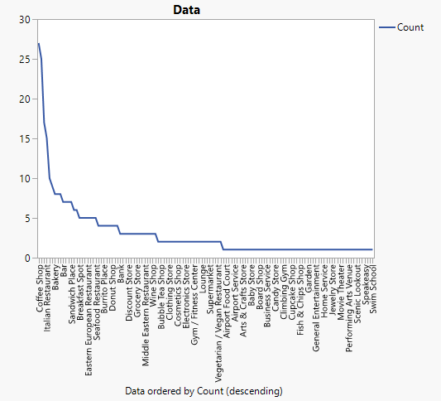

Restaurants are important, but the two cities have varying tastes in food. Pizza, sandwich shops and Japanese/sushi are popular in New York. Given the fast-paced centric mindset we can understand why pizza and sandwich shops are more popular. Sandwiches are popular in Toronto, but Italian food is more popular. Bakeries are also more popular in Toronto. These differences would have to be explored further, but these could be cultural differences between the two cities. Both cities have a similar number of natural attractions with greenspace for residence.

**Observations**

From the results we see a few similarities in attractions that the population finds attractive, but one thing that we cannot extrapolate from this is rational without digging in deeper. From previous experience coffee shops are a great place to meet people. Both businesses provide a great listing of locations for meeting up with one another. I believe there are exceptions to this in regard to a bakery and gym.

**Conclusions**

While there are similarities between the two cities there are also stark contrasts. People look for places to meet and mingle whether its over a cup of coffee to a place to eat. Each city has its own appeal to people while it could be said that there is more to do in New York given the population Toronto has a closer feel to nature since not much is as built around the surrounding city.